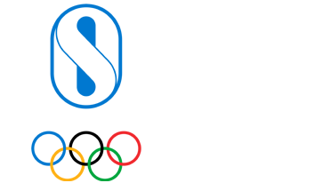

Application Details

Programme Selection

Category
World Programmes
Programme Cluster / Continent
Sport Development

Programme
Youth Athlete Development - Identification and Training

Quad/Games Edition

2021- 2024

Programme (Long Form)
Youth Athlete Development - Identification and Training

Programme Help/Instructional Text
Please complete your application with all the annual identification and training events for which your NOC wishes to receive support, bearing in mind the annual budget available is maximum USD 25,000. One application can be submitted per year and the reporting must be completed before submitting an application for a following year.
Activities (including Dates and Venues)
Note: Please attach the List of Athletes who will participate in the activities.

Budget Proposal
Description Amount (USD)

